NOVEL

SCM Channel Purchase Order Shipment and Warehouse Inventory Management System
  - Product Requirements Document
A clear view of how Novel will manage purchase orders, warehouse stock, appointments, shipments, proof of delivery and invoices in one controlled system.
Document | Details
Version | 1.0
Date | 2 October 2026
Status | For client review
Primary users | Associates / Processors, Managers, Director Admins, Super Admins and QC Users

1 Executive Overview
  - What the product will do and why it matters
The product will give Novel one shared operational record for every purchase order. It will replace separate Excel trackers, email chains, manual stock calculations and unstructured WhatsApp updates with a guided workflow from PO upload to final closure.
The system will protect warehouse stock, show pending work, track multiple trucks, reconcile deliveries and retain a complete history of important actions.
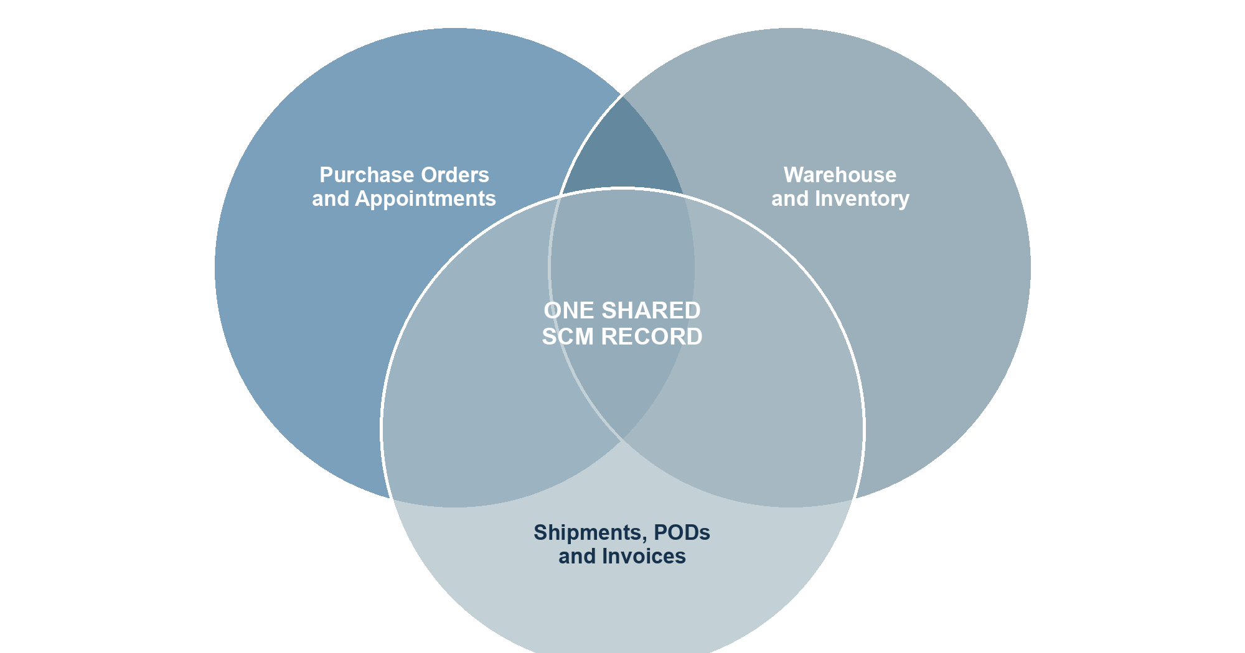
Figure 1 The system connects commercial, warehouse and delivery information

Expected business outcomes
- The SCM team can operate without a separate Excel tracker.
- Every PO, appointment, shipment, POD and invoice can be found from one PO record.
- Protected stock cannot be allocated through the normal workflow.
- The same stock cannot be reserved for two POs at the same time.
- Pending work and exceptions are visible without searching email or WhatsApp history.
- Every important change is linked to a user and timestamp.

2 Business Need and Scope
  - The current challenges and the agreed MVP boundary

Current challenges
Current issue | Business effect
PO details are copied by hand | Repeated work and a higher chance of errors
Stock is calculated in separate files | The same stock can be promised more than once
Updates are spread across email and WhatsApp | Delays and missing information are hard to identify
POs can be split across several trucks | Shipment and delivery quantities are difficult to reconcile
Documents are stored separately | PODs and invoices are hard to trace back to the correct PO

MVP scope
Included | Not included
PO and appointment PDF upload and review | Production planning, MRP and demand forecasting
Warehouse assignment, stock thresholds and reservations | Invoice, GST, e-invoice or e-way-bill generation
Multi-truck shipment planning and manual updates | Automatic WhatsApp ingestion or live GPS tracking
POD, delivery differences and short-close approval | Marketplace API integration or appointment booking
Invoice upload, alerts, reports and audit history | Accounting or Tally posting

Users and responsibilities
User | Main responsibilities
Associate / Processor | Runs daily PO, shipment, POD and invoice activities
Manager | Approves operational exceptions, warehouse overrides and short closes
Director / Director Admin | Maintains run rate, lead time, thresholds and mappings; reviews management reports
Super Admin | Manages users, roles, master data and system settings
QC User | Views operational records and audit history without making changes

3 Complete Operating Workflow
  - The journey of a purchase order from receipt to closure
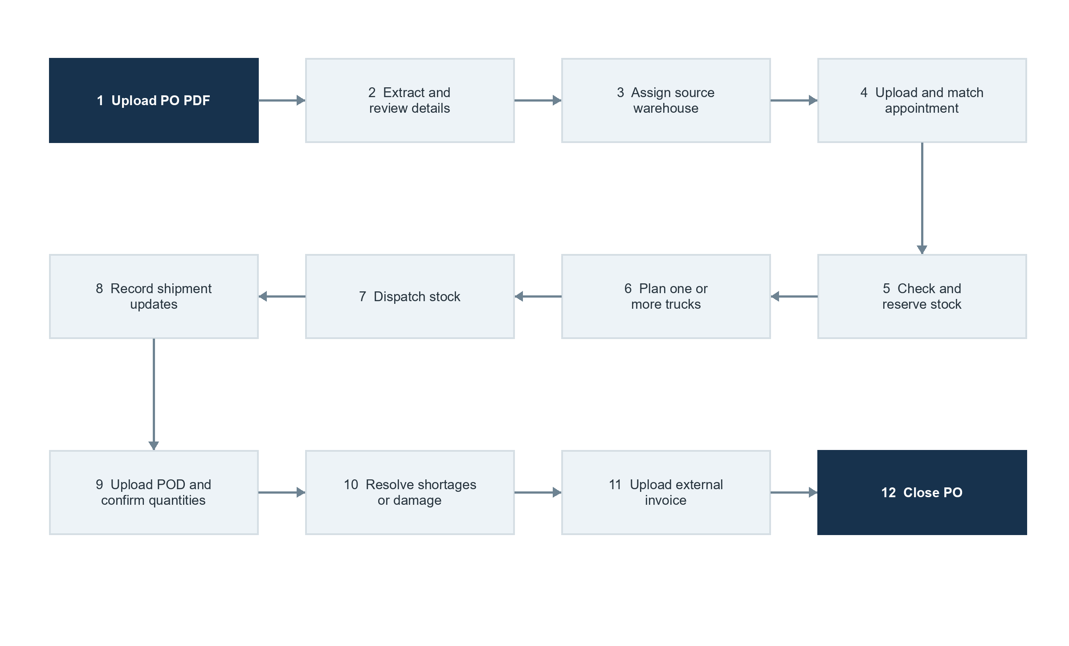
Figure 2 Complete PO to invoice workflow
The appointment document is uploaded and matched before stock levels are checked. A rejected PO closes without reserving stock. An accepted PO reserves available stock. Shipment planning starts only after the appointment is present and the PO is accepted. Inventory leaves company ownership only when the delivered quantity is confirmed through POD.

Key control points
- A person reviews extracted PDF data before the PO is accepted.
- The system checks stock after the appointment is matched and rechecks it when the reservation is created.
- Combined shipment quantities cannot exceed the blocked PO quantity.
- Only confirmed delivered quantities are deducted after POD review.
- Invoice upload is allowed only after full delivery or an approved short close.

4 Purchase Order Appointment and Warehouse Assignment
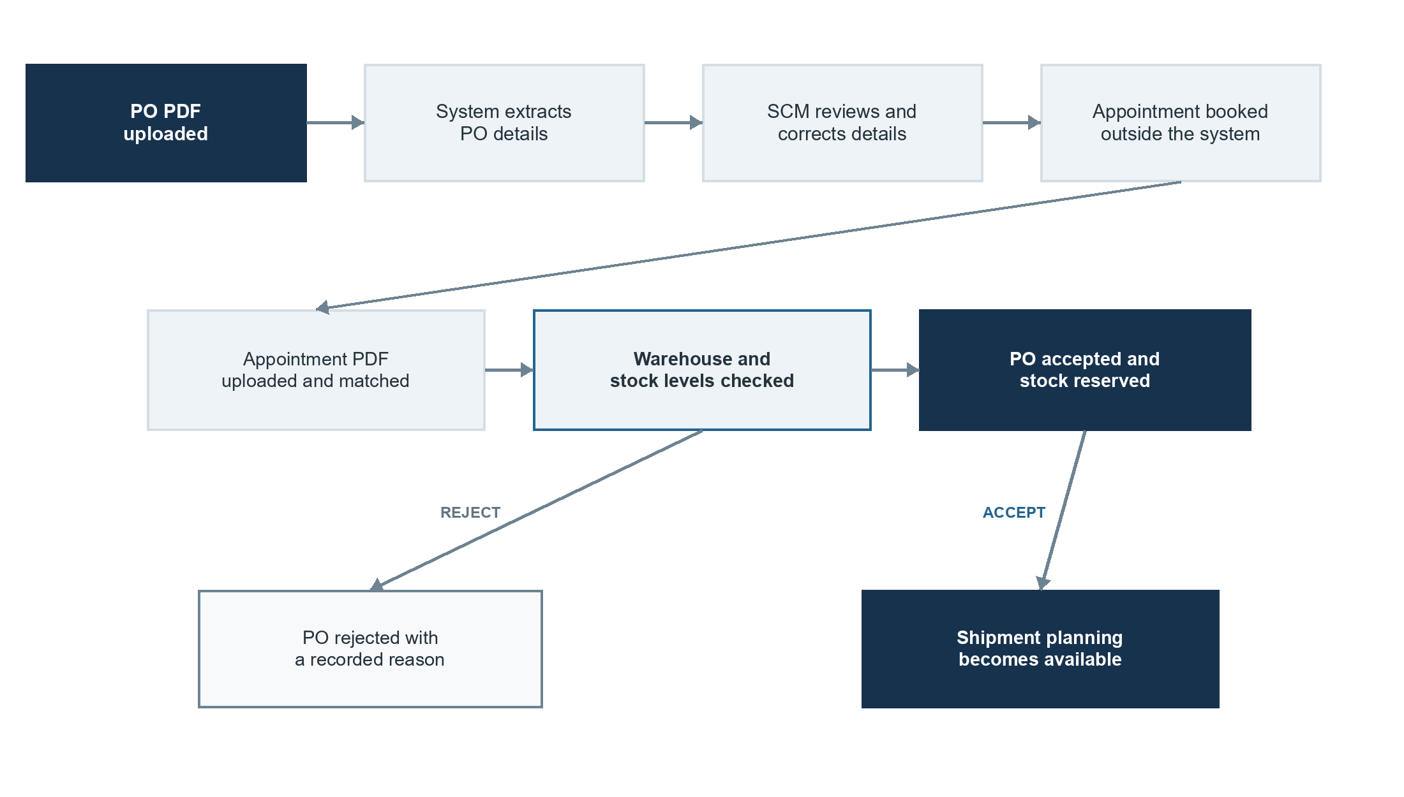
Figure 3 PO and appointment workflow

PO processing
The original PO PDF is stored. The system extracts available details such as PO ID, dates, destination, SKU, quantities, prices and delivery instructions. The user checks and corrects the values before acceptance. A platform and PO ID combination must be unique.

Appointment processing
Appointment booking remains outside the product. After booking, the team uploads the appointment PDF before the inventory check. The system matches it to the PO using the PO ID. If matching fails or gives more than one result, the user selects the PO manually. Earlier document versions remain in history when a replacement is made.

Warehouse assignment rules
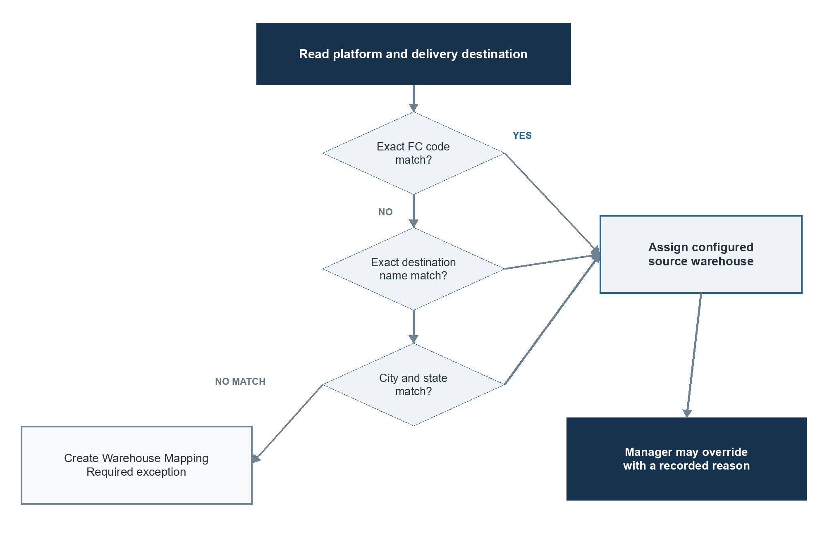
Figure 4 Warehouse assignment decision
The system never switches warehouses silently because of a shortage. A Manager, Director Admin or Super Admin may override the assigned warehouse only with a recorded reason.

Assignment controls
- The assigned source warehouse is visible before PO acceptance.
- Missing mappings create a Warehouse Mapping Required exception.
- Stock at other warehouses is shown for information when a shortage exists.
- Every approved warehouse override is recorded in the audit history.

5 Warehouse Inventory and Stock Protection
Inventory is managed for each SKU in each warehouse. Users do not edit calculated balances directly. Stock additions, reservations, dispatches, deliveries and corrections are recorded as permanent inventory movements.
Stock quantity | Plain-language meaning
Physical stock | Stock recorded at the warehouse, excluding dispatched stock
Threshold stock | Protected minimum stock that normal PO allocation cannot use
Blocked stock | Stock reserved for accepted POs but not yet dispatched
Available stock | Physical stock minus blocked stock
Allocatable stock | Physical stock minus blocked stock and threshold stock
In-transit stock | Dispatched stock still owned by Novel

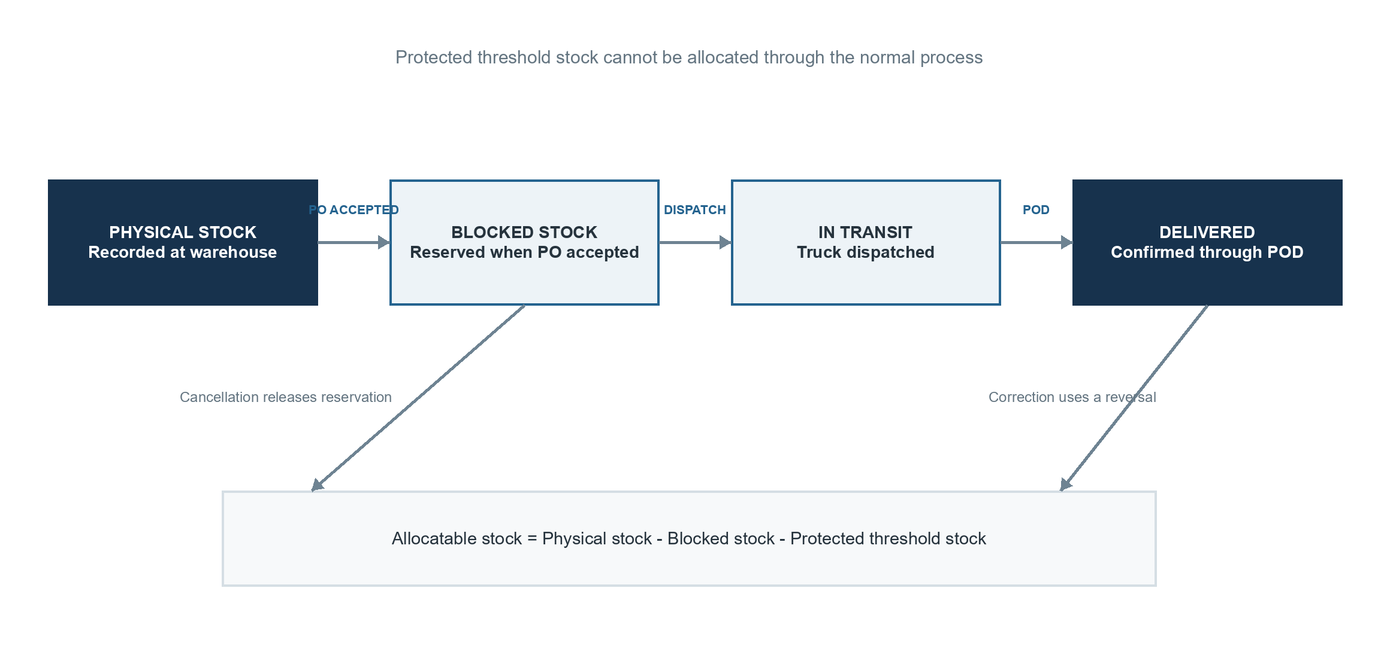
Figure 5 Inventory movement through the PO lifecycle

Shortage handling
Threshold stock is maintained from the daily sales run rate and supplier lead time. For the MVP, the Director Admin enters these values manually. The system calculates the threshold as daily sales run rate multiplied by lead time plus a three-day safety buffer.
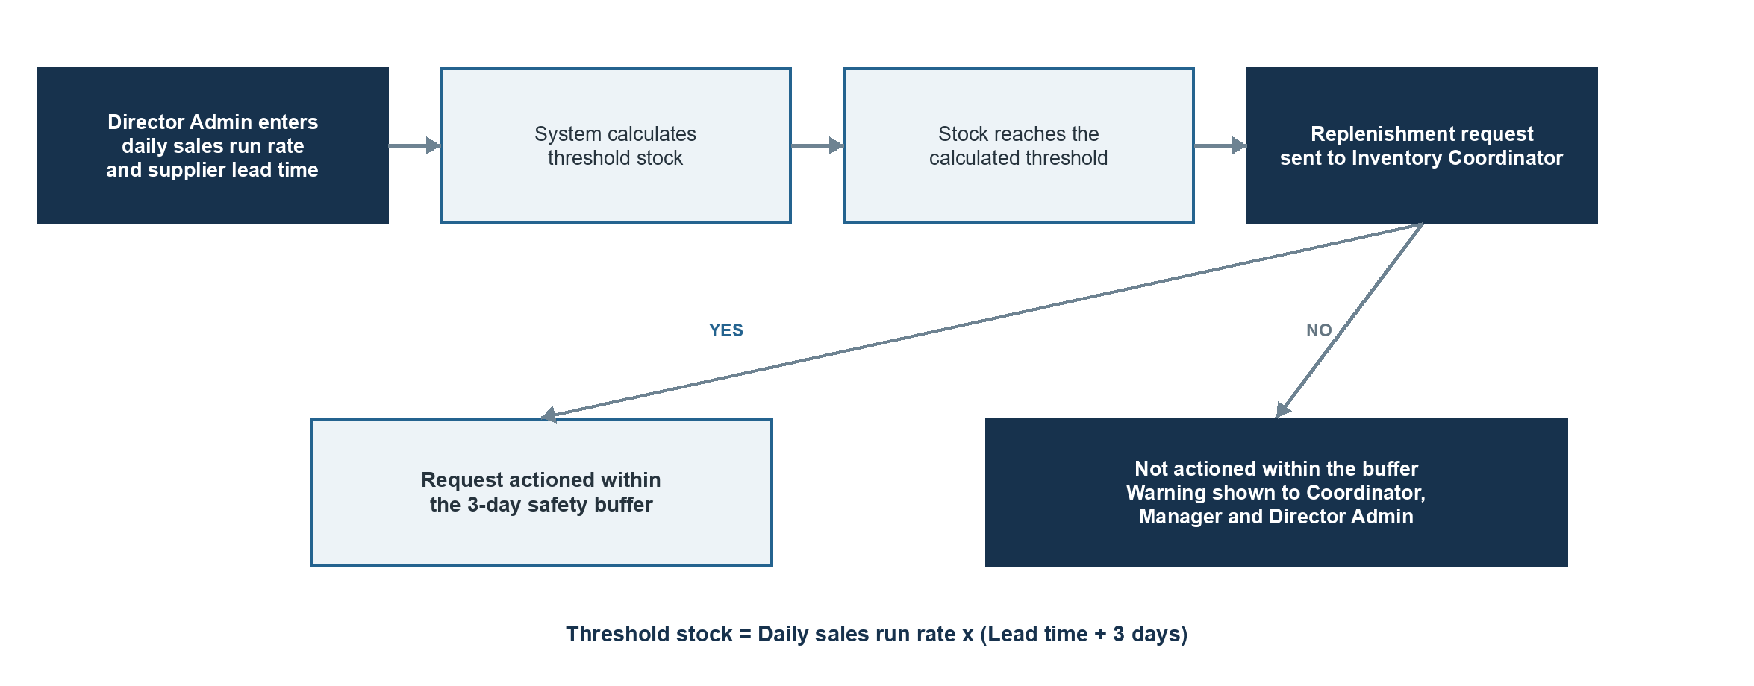
Figure 6 Threshold monitoring and replenishment request flow
When stock reaches the calculated threshold, the system raises a replenishment request for the Inventory Coordinator. The request must be actioned within the three-day safety buffer before the normal replenishment lead time begins. If it is not actioned, the system raises a warning for the Inventory Coordinator, Manager and Director Admin.
When stock is insufficient for a PO, the screen shows the required, physical, blocked, threshold, allocatable and shortage quantities. The team may wait for replenishment, allocate the remaining quantity later, request a warehouse override, use an approved backup warehouse, split fulfilment after approval, reject the PO or approve a short close.

6 Shipment Delivery POD and Invoice
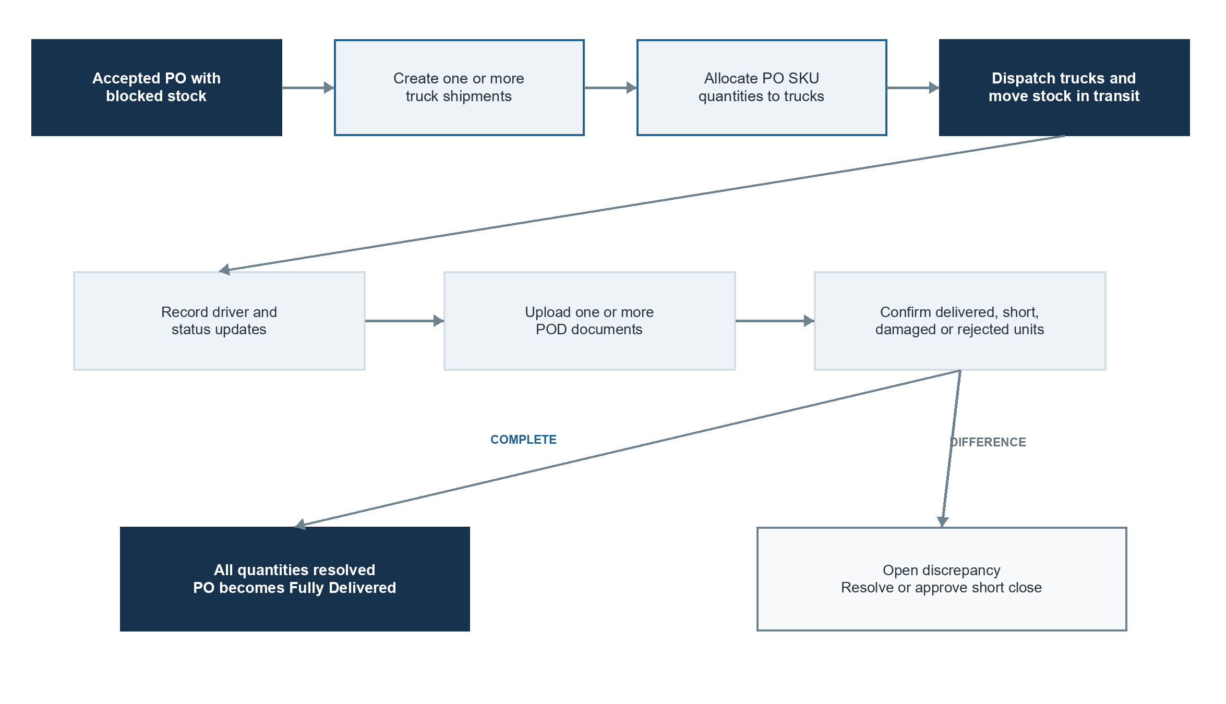
Figure 7 Multi-truck shipment and delivery process

Shipment planning
One PO may be divided across several trucks and SKUs. Each shipment records the source warehouse, destination, vehicle, transporter, driver, planned dates, actual dates, estimated cost, actual cost and SKU quantities. The total planned quantity cannot exceed the blocked stock.

Proof of delivery
One or more POD documents may be uploaded. The team confirms received, short, damaged and rejected quantities by SKU. Only confirmed delivered quantities are removed from in-transit stock. Remaining quantities stay unresolved until their final handling is recorded.

Invoice and closure
The invoice is created outside the system. One invoice is uploaded for each PO only after full delivery or approved short close. The PO closes only when shipments and delivery differences are resolved and the invoice is present.

7 How Information Moves Through the System
  - Documents, decisions and stock movements remain connected to the same PO
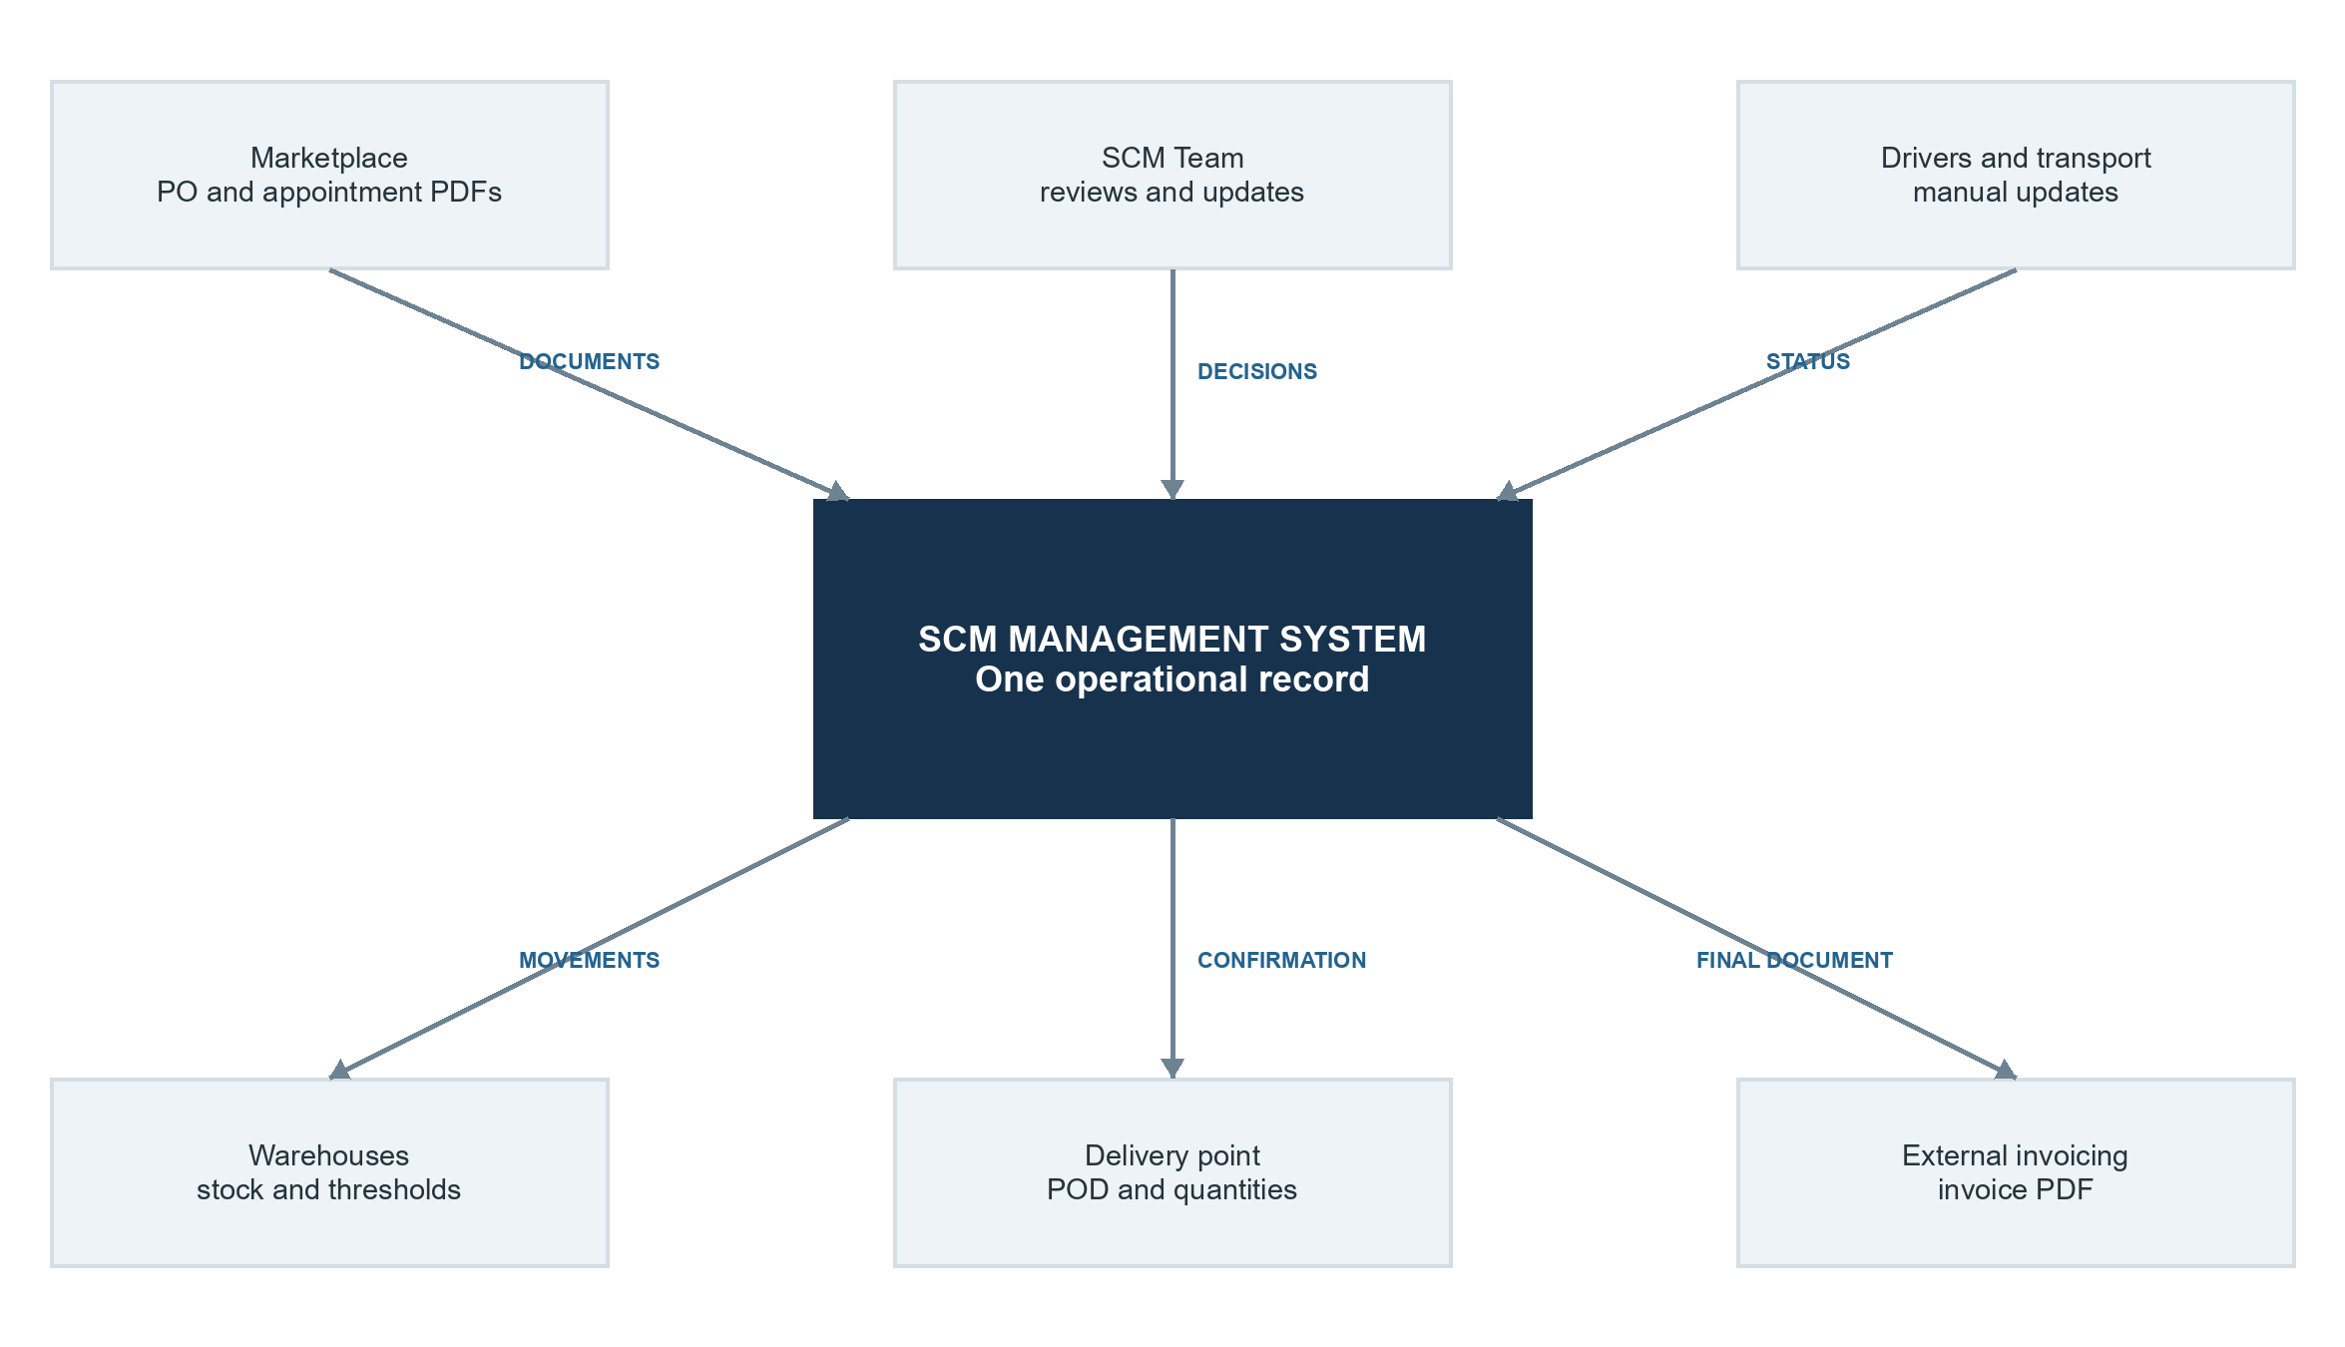
Figure 8 High-level business data flow

Main connected records
Information group | What is stored
Purchase order | PO details, line quantities, prices, destination, status and source PDF
Warehouse and inventory | Warehouse mapping, thresholds, balances, reservations and movements
Appointment | Appointment ID, date, location, status and document versions
Shipment | Truck, driver, route, cost, dates, quantities and status events
Delivery | POD documents, received quantities, shortages, damage and open differences
Invoice and notification | Invoice details, sending status, retries and recipients
Audit history | Who performed each important action, when it occurred and what changed

The PO details page acts as the main operational view. It brings together the source PDF, line reconciliation, warehouse, reservation, appointment, shipments, PODs, invoice, notifications and full activity history.

8 Operational Screens Queues and Reports

Main working screens
Screen | Purpose
Dashboard | Shows pending work, approaching deadlines, delays and exceptions
PO Inbox and Details | Uploads, reviews and manages the complete PO record
Appointment Queue and Calendar | Tracks booking deadlines, dates and matching failures
Inventory | Shows physical, threshold, blocked, allocatable, in-transit and shortage quantities
Replenishment Queue | Shows threshold requests, Inventory Coordinator action and overdue warnings
Shipment Planner and Tracker | Plans trucks, assigns quantities and records movement updates
POD and Invoice Queues | Shows missing PODs, delivery differences and invoices still required
Administration and Audit | Manages master data and searches the permanent history

Required alerts
- Extraction failure, duplicate PO or missing warehouse mapping.
- Appointment deadline approaching or appointment document missing.
- Insufficient stock, threshold concern or unresolved shortage.
- Replenishment request not actioned within the three-day safety buffer.
- Shipment dispatch delay, late arrival or missing POD.
- Delivery mismatch, in-transit quantity still open or invoice pending.
- Email delivery failure with a safe retry option.

Reports
Exportable reports cover PO status, acceptance and rejection, appointment performance, warehouse assignments, inventory, threshold calculations, replenishment requests, shortages, blocked and in-transit stock, fulfilment, shipment cost and time, POD ageing, delivery differences, pending invoices and user actions.

9 Permissions Audit Security and Reliability

Permission boundaries
Controlled action | Allowed role
Daily PO, shipment, POD and invoice processing | Associate / Processor, Manager, Director Admin or Super Admin
Warehouse override and short-close approval | Manager, Director Admin or Super Admin
Run rate, lead time and threshold changes | Director Admin or Super Admin
Users, roles and system settings | Super Admin
View operational and audit records | QC User and operational roles

How the interface changes by role
All roles use the same core screens. Navigation, actions and edit controls change by permission, so users see only the controls allowed for their role.
Role | UI access and available actions
Associate / Processor | Operational queues; edits PO, appointment, shipment, POD and invoice records
Manager | Processor controls plus approvals, overrides, exceptions and short closes
Director / Director Admin | Manager visibility plus run rate, lead time, threshold, mapping and report controls
Super Admin | All administration controls, including users, roles, master data and settings
QC User | View only; no create, edit, approve, upload or delete controls

Permanent audit history
The append-only audit log records the user, role, server time, action, old and new values, reason, and related PO, shipment, SKU or warehouse.

Security and reliability requirements
- All users authenticate; Manager, Director Admin and Super Admin accounts support multi-factor authentication.
- The server checks every restricted action; data and documents are encrypted.
- Reservation, dispatch and POD actions prevent duplicates; failed jobs enter a safe retry queue.
- Daily backups and a restore test are required; business records are never hard-deleted.

10 Delivery Plan Testing and Go Live
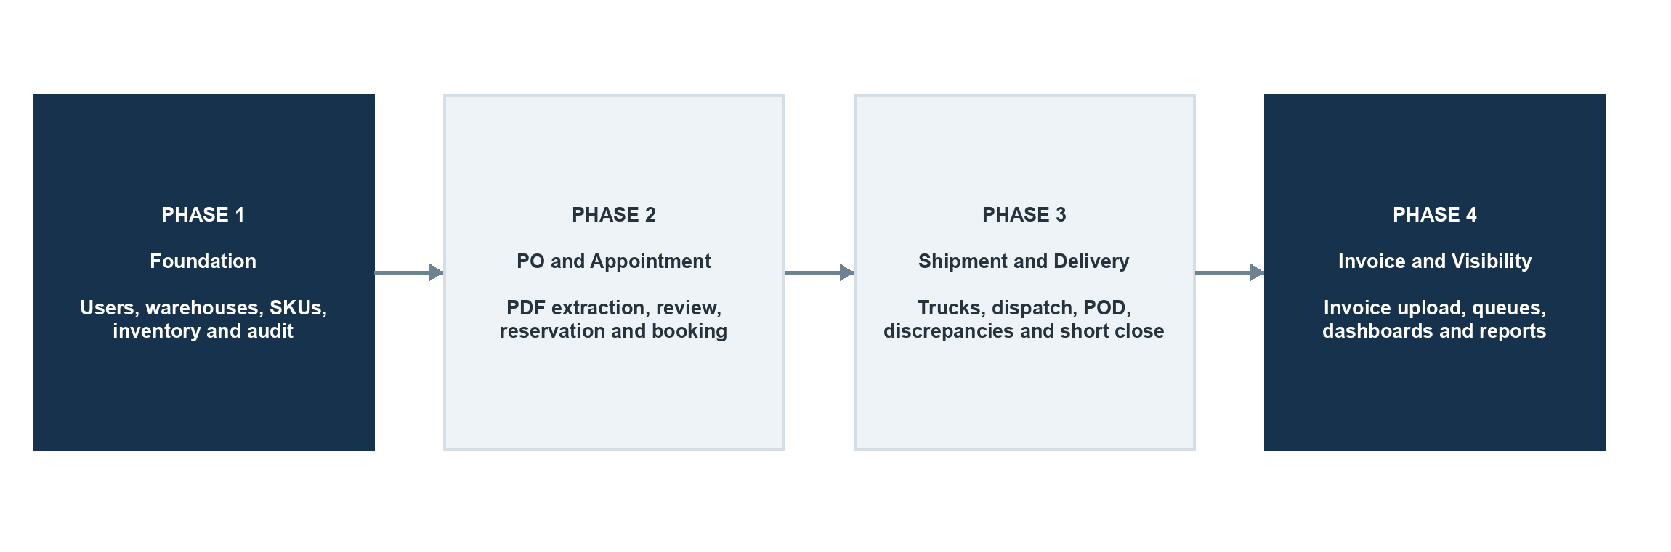
Figure 9 Four-phase delivery plan

Testing coverage
Test area | Required focus
Business rules | Extraction, mappings, formulas, thresholds, statuses and permissions
Connected workflow | Acceptance, reservation, appointment, dispatch, POD, short close and invoice
Concurrency | Two users competing for the same last available stock
Documents | Duplicates, unreadable files, incorrect IDs and matching failures
Recovery | Email retry, extraction retry, safe job replay and backup restoration
End to end | A complete multi-truck PO from upload through closure

Go-live readiness
- Warehouse mappings, active SKUs and threshold quantities are approved and loaded.
- Opening physical inventory is entered and reconciled.
- Roles, permissions and inventory concurrency tests pass.
- A real PDF from every supported platform is tested.
- Multi-truck delivery, partial delivery and POD correction are tested.
- Restricted actions appear correctly in the audit log.
- A backup is restored successfully into a clean environment.

11 Product Acceptance and Client Review
  - The conditions that show the solution is working as intended

The product is accepted when
- Supported PO PDFs can be uploaded, extracted, reviewed and accepted without creating duplicate POs.
- Destinations select the configured warehouse, while missing mappings create a visible exception.
- Protected threshold stock cannot be reserved and concurrent acceptance cannot reserve the same units twice.
- Appointment documents match to the correct PO and shipment planning remains locked until the document is present.
- One PO can be split across multiple trucks without exceeding the blocked quantity.
- Dispatch moves stock into transit, while POD confirmation removes only delivered quantities.
- Short, damaged and rejected quantities remain visible until resolved.
- Invoice upload remains blocked until full delivery or approved short close.
- QC users can view permitted records but cannot change them.
- Every required action creates a permanent audit event.
- Inventory balances can be rebuilt from movement records and match the displayed values.
- The team can complete the full workflow without an Excel operations tracker.

Decision requested from Novel
Review the workflow, user responsibilities, approval points, inventory rules, document handling and delivery phases. Confirm that the described process reflects the intended SCM operation before detailed product design and implementation begin.

12 Client Inputs Required
  - Information and access needed to confirm the workflow and support implementation
Novel should provide the primary items below during discovery. The optional platform access is needed only if automatic PO ingestion is included.

Primary requirements
- Sample PO PDF files representing the formats currently received.
- Sample communication emails exchanged between the teams during PO, appointment, inventory, shipment, POD and invoice handling.
- Current Excel sheets used to manage and track the SCM process.

Optional requirements
- Platform API keys or access credentials for automatic PO ingestion, including Amazon, Meesho, Flipkart and other applicable platforms.
End of Product Requirements Document

